Spiral Model

🧠 Definition
# Source: AI Source: Provided by: [Data Path: Persons Table -> ID Column: 1, Name_En Column: Motasem Essam] -> From: [ChatGPT] on [1/23/2026]
The Spiral Model is a risk-driven Software Development Life Cycle (SDLC) model that combines elements of both Waterfall and Agile approaches. It focuses on continuous risk assessment and iterative development through repeated cycles called spirals.
The Spiral Model is an iterative development process where each cycle (spiral) includes planning, risk analysis, development, and evaluation, with a strong emphasis on identifying and managing risks.

🔄 Phases of Spiral Model
# Source: AI Source: Provided by: [Data Path: Persons Table -> ID Column: 1, Name_En Column: Motasem Essam] -> From: [ChatGPT] on [1/23/2026]
Each spiral consists of the following phases:

📋 Planning
# Source: AI Source: Provided by: [Data Path: Persons Table -> ID Column: 1, Name_En Column: Motasem Essam] -> From: [ChatGPT] on [1/23/2026]
- Define objectives, requirements, and alternatives
- Identify project goals for the current iteration

⚠️ Risk Analysis
# Source: AI Source: Provided by: [Data Path: Persons Table -> ID Column: 1, Name_En Column: Motasem Essam] -> From: [ChatGPT] on [1/23/2026]
- Identify potential risks (technical, financial, operational)
- Evaluate and find solutions to minimize risks
- This is the most important phase of the Spiral Model

🏗️ Engineering (Development)
# Source: AI Source: Provided by: [Data Path: Persons Table -> ID Column: 1, Name_En Column: Motasem Essam] -> From: [ChatGPT] on [1/23/2026]
- Design and develop the system or part of it
- Implement features based on planning

🔍 Evaluation
# Source: AI Source: Provided by: [Data Path: Persons Table -> ID Column: 1, Name_En Column: Motasem Essam] -> From: [ChatGPT] on [1/23/2026]
- Test and evaluate the developed product
- Gather feedback from users or stakeholders
- Decide whether to proceed to the next spiral

🔁 How Spiral Model Works
# Source: AI Source: Provided by: [Data Path: Persons Table -> ID Column: 1, Name_En Column: Motasem Essam] -> From: [ChatGPT] on [1/23/2026]
- Development progresses through multiple spirals (iterations)
- Each spiral improves the system gradually
- Risks are analyzed and reduced at every stage
- The process continues until the final product is complete

⚙️ Key Characteristics
# Source: AI Source: Provided by: [Data Path: Persons Table -> ID Column: 1, Name_En Column: Motasem Essam] -> From: [ChatGPT] on [1/23/2026]
- Risk-driven approach
- Combines iterative and sequential development
- Continuous user feedback and evaluation
- Flexible and allows changes during development
- Suitable for large and complex projects

✅ Advantages
# Source: AI Source: Provided by: [Data Path: Persons Table -> ID Column: 1, Name_En Column: Motasem Essam] -> From: [ChatGPT] on [1/23/2026]
- Early identification and mitigation of risks
- Flexible and adaptable to changes
- Continuous customer feedback improves quality
- Suitable for complex and high-risk projects
- Better control over project development

⚠️ Disadvantages
# Source: AI Source: Provided by: [Data Path: Persons Table -> ID Column: 1, Name_En Column: Motasem Essam] -> From: [ChatGPT] on [1/23/2026]
- Complex to manage
- Requires expertise in risk analysis
- Higher cost due to repeated iterations
- Not suitable for small or low-risk projects

📝 When to Use Spiral Model
# Source: AI Source: Provided by: [Data Path: Persons Table -> ID Column: 1, Name_En Column: Motasem Essam] -> From: [ChatGPT] on [1/23/2026]
- Projects with high risk and complexity
- Large-scale systems requiring frequent evaluation
- When requirements are uncertain or evolving
- Projects needing strong risk management

⚖️ Spiral Model vs Agile Model

Key Difference (In One Line)
# Source: AI Source: Provided by: [Data Path: Persons Table -> ID Column: 1, Name_En Column: Motasem Essam] -> From: [ChatGPT] on [1/23/2026]
- Agile Model → Focuses on fast delivery & customer feedback
- Spiral Model → Focuses on risk analysis & risk reduction

Detailed Comparison
# Source: AI Source: Provided by: [Data Path: Persons Table -> ID Column: 1, Name_En Column: Motasem Essam] -> From: [ChatGPT] on [1/23/2026]
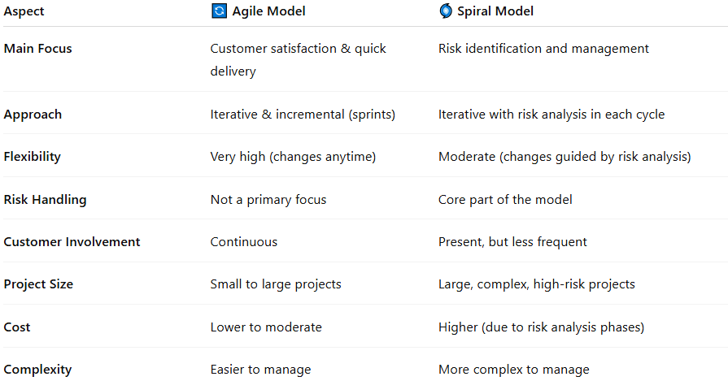
Aspect | 🔄 Agile Model | 🌀 Spiral Model
Main Focus | Customer satisfaction & quick delivery | Risk identification and management
Approach | Iterative & incremental (sprints) | Iterative with risk analysis in each cycle
Flexibility | Very high (changes anytime) | Moderate (changes guided by risk analysis)
Risk Handling | Not a primary focus | Core part of the model
Customer Involvement | Continuous | Present, but less frequent
Project Size | Small to large projects | Large, complex, high-risk projects
Cost | Lower to moderate | Higher (due to risk analysis phases)
Complexity | Easier to manage | More complex to manage

Why They Feel Similar
# Source: AI Source: Provided by: [Data Path: Persons Table -> ID Column: 1, Name_En Column: Motasem Essam] -> From: [ChatGPT] on [1/23/2026]
Both models:
- Use iterations (repeated cycles)
- Allow feedback and improvements
- Do not follow strict linear steps like Waterfall
👉 That’s why they often seem the same—but their goal is different.

Simple Analogy
# Source: AI Source: Provided by: [Data Path: Persons Table -> ID Column: 1, Name_En Column: Motasem Essam] -> From: [ChatGPT] on [1/23/2026]
- Agile Model 🏃‍♂️
Like building an app step by step and showing it to users every week for feedback.
- Spiral Model 🧠
Like building a system but stopping at every step to analyze risks before continuing.

Final Verdict
# Source: AI Source: Provided by: [Data Path: Persons Table -> ID Column: 1, Name_En Column: Motasem Essam] -> From: [ChatGPT] on [1/23/2026]
You’re partially right—they share iterative behavior, but:
- Agile = speed + flexibility + user feedback
- Spiral = safety + risk control + careful planning

📌 Summary
# Source: AI Source: Provided by: [Data Path: Persons Table -> ID Column: 1, Name_En Column: Motasem Essam] -> From: [ChatGPT] on [1/23/2026]
The Spiral Model is a risk-focused SDLC model that combines iterative development with systematic risk analysis. Each cycle includes planning, risk evaluation, development, and testing, making it ideal for large, complex, and high-risk projects. While powerful, it requires expert management and higher costs, making it less suitable for smaller projects.

